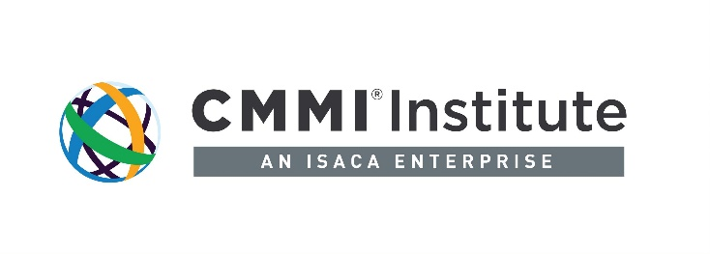

Benchmarking That Drives Business Performance

Today, almost all organizations are under increasing pressure to maximize performance and efficiency to maintain a competitive edge. But “competitive edge” is a comparative issue by definition. So, in today’s highly competitive global business environment, how does your organization actually measure up against its competitors? If you don’t know, where do you start to find out?
Benchmarking has become a widely accepted method for understanding how your organization compares to others, and then using those comparative insights to improve performance and competitiveness. Robert Camp, a key early proponent of benchmarking techniques, neatly captured its essence: The Search for Industry Best Practices that Lead to Superior Performance.
By enabling companies to compare their own processes with best practices within their industry (and across other industries), benchmarking leads to a better understanding of your strengths and weaknesses—and where to improve to achieve the maximum increase in efficiency and competitiveness. For example, if you’re providing services or producing software or hardware, how efficient and effective is your development process or your customer-service operation, compared to industry best practices? In a fast-moving business environment, that information can be critical to determine how well you’re positioned to maintain profitability and respond to new market demands and challenges.
But the primary benefit of benchmarking is in improving performance, not simply knowing how well your practices measure up against others. That requires using the knowledge gained from benchmarking to innovate: to generate ideas for driving measurable improvements in your own business practices.
Many companies have driven innovation by benchmarking within their own industry—or outside their industry, in some cases. Southwest Airlines famously analyzed the processes of car-racing pit crews to gain ideas for improving airplane turn-around time between flights—improving performance and saving millions by doing so. A hospital in India figured out how to bring cataract surgery to the masses, thus restoring the eyesight of many thousands of people, by adopting assembly-line techniques from manufacturing.
Benchmarking is not limited to the private sector: Government agencies have also benchmarked functions such as customer service against other agencies and relevant the private sector companies, to improve customer satisfaction and use resources more efficiently.

How CMMI® V2.0 Enables Benchmarking

Today, organizations have access to a model that facilitates benchmarking and performance optimization in a single platform: Capability Maturity Model Integration (CMMI) V2.0. The CMMI V2.0 platform provides a proven set of global best practices for specific capabilities within an organization. It enables commercial businesses and public-sector organizations to compare their processes against industry best practices in specific operational areas. And it enables organizations to better understand and assess their own practices—an essential prerequisite for learning how to improve them.
Companies of all sizes, as well as government agencies, use CMMI to quickly identify the practices that directly impact key aspects of business performance such as quality, cost and time to market. Then they can use the best practices in the CMMI framework to drive performance improvements. CMMI V2.0 is highly flexible and modular, so businesses—or even small teams within a business—can pick and choose the elements that matter most to them. Companies in fast-moving industries can focus on areas that are essential to maintain a competitive edge. “Every organization has one or more constraints, the trick is you have to focus your priorities on what means the most to the business,” says Ron Lear, Chief Architect of CMMI V2.0. “CMMI gives you that targeting mechanism.”

Pinpoint the Cause of Problems

CMMI gives organizations the tools to understand not just where their performance may be less than optimal, but why, and then it goes one step further by providing guidance on what to do to address that performance. Many organizations track important metrics of business performance, such as quality, time to market or budget performance—but when those metrics fall below expectations, they don’t always have a good understanding of the cause. CMMI V2.0 enables organizations to pin down the reasons. “I often hear from organizations that they’re trying to get better at what they do—they know they can probably do things faster, at less cost, but they’re not sure how,” Lear says. “CMMI provides insights into the processes that determine your time to market, where they need improvement, and where to focus. It removes intuition and augments (or replaces) it with data.”
For example, if a company is delivering software late or over budget, and losing money as a result, it can use the model to examine its development processes, pinpoint areas where they lag industry best practices, and target those areas for improvement. The platform also equips organizations with example activities and work products as well as the knowledge that can help them respond more quickly to new competitors; armed with a comprehensive understanding of its current development processes and capabilities, an organization can more quickly figure out what needs to change in order to adapt to a changing competitive landscape.

Preparing for the Future

In business, change is inevitable. To be prepared for what the future will bring, organizations must be constantly looking for ways to improve performance, efficiency, and competitiveness. Repeatable, consistent benchmarking is a proven method for understanding how your organization measures up, and for gaining new perspectives on how to improve. With CMMI V2.0, organizations have access to a broad set of industry best practices and methods that can be used to benchmark key functions and drive innovations that increase business performance.

